CURRICULUM VITAE

**PERSONAL DETAILS - *Md. Tangim Hossain Akash***

*Residential Address:* House #13, Road#9, Sector#10, Uttara Dhaka 1230

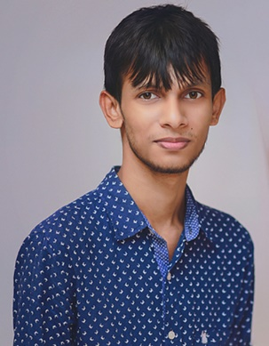

*Date of Birth:* 25 March 1994

*Nationality:* Bangladeshi

*Sex:* Male

Religious Views: Muslim

*Mobile:* 01674961499

*Email:* [tangim16@gmail.com](mailto:tangim16@gmail.com)

*Area Of Interest: Photography. Love to capture the moment of life,* I do

love to capture beauty in this world & Travelling.

**EDUCATION HISTORY**

Jan 2015 – Current **North South University**, Dhaka, Bangladesh

*Studying School Of Electrical & Computer Engineering*

*B.S. Computer Science and Engineering*

June 2011 – Apr 2013 **Rajuk Uttara Model College**, Uttara, Dhaka. Bangladesh

*Studied Science Section*

*Higher Secondary School Certificate equivalent*

Jan 2001 – Jan 2011 **Uttara High School**, Uttara, Dhaka. Bangladesh

*Studied Science Section*

*Secondary School Certificate equivalent*

**WORK EXPERIENCE**

|  |  |
| --- | --- |
| Jan 2015 – Current  Oct 2015 – Current | **NSU Art & Photography Club,** Dhaka, Bangladesh  Club Member  **NSU Computer & Engineering Club,** Dhaka, Bangladesh  Club Member |

**OTHER SKILLS AND CERTIFICATES**

**Computer Skills:**

* Microsoft Applications - (Word, Excel, Office, PowerPoint, Outlook, Access) – Advanced
* Microsoft Office Document Imaging and Scanning - Advanced
* Adobe Photoshop, Lightroom, Illustrator - Advanced
* Fidelio Front Office Systems 6.02 – Beginner
* Gaming Problem Solution
* Web Design

**Language Skills:**

* Bangla - Native Tongue)
* English - Basic (Reading and Writing Skills)

**INTERESTS AND ACTIVITIES**

* Cricket, Football, Cycling, Badminton.

**PARENTS DETAILS**

|  |  |
| --- | --- |
| Father Details:      Mother Details: | Md. Anowar Hossain Govt. officer, General Manager Post, Sonali Bank Limited Dhaka Bangladesh.  Tahmina Begum Housewife. |